**Phase 5**

**Course-end Project 1**

**Developer Details :**

**Seelam Sindhuja**

**Email: ssindhuja@teksystems.com**

**Emp Id : 10840**

**Project Objective :**

Build an Angular app where users can read and add blog posts.

**Project Overview :**

Project builds a food blog app where users can read, write, edit or delete new and existing posts .

**Project Capability :**

The project is capable of displaying existing food blogs and allows users to create new blogs and can also update, delete existing food blogs in the app.

**Project Appearance :**

Project screen appearance consists of a single screen showing all the blogs and redirects to a new page when to create a new blog in the app.

**User Interactions :**

Users can interact with the app through first screen which allows them to perform creating new blogs and updating existing blogs as per their requirements.

**Project Git hub link :**

<https://github.com/SindhujaSeelam/angulardemos/tree/main/myapp/src/app/foodblogproject>

**Sprint Planning :**

I have divided project into 3 sprints.

Sprint 1:

In sprint 1 I have configured all the requirements of the project at first and then designed rough outline of the project. I have first started to designing JSON file consisting of different predefined blogs.

Sprint 2:

In sprint 2 I have designed all the components of the app, where I took three components namely foodblogproject component which includes other two components singleblog component and update component.

I took singleblog component to display every single blog and update component to update existing component. Main form to create new blog is kept in foodblogproject component.

Sprint 3:

In sprint 3 I have implemented all front end designing to have easy interaction for the users and also coded all the exceptions that can happen while using application and made connection between all the components and html pages.

**Concepts Used:**

* JSON Server
* Angular
* Ng Modules
* Html
* Css
* bootstrap
* json files
* Nav Component

**Flowchart of the program**

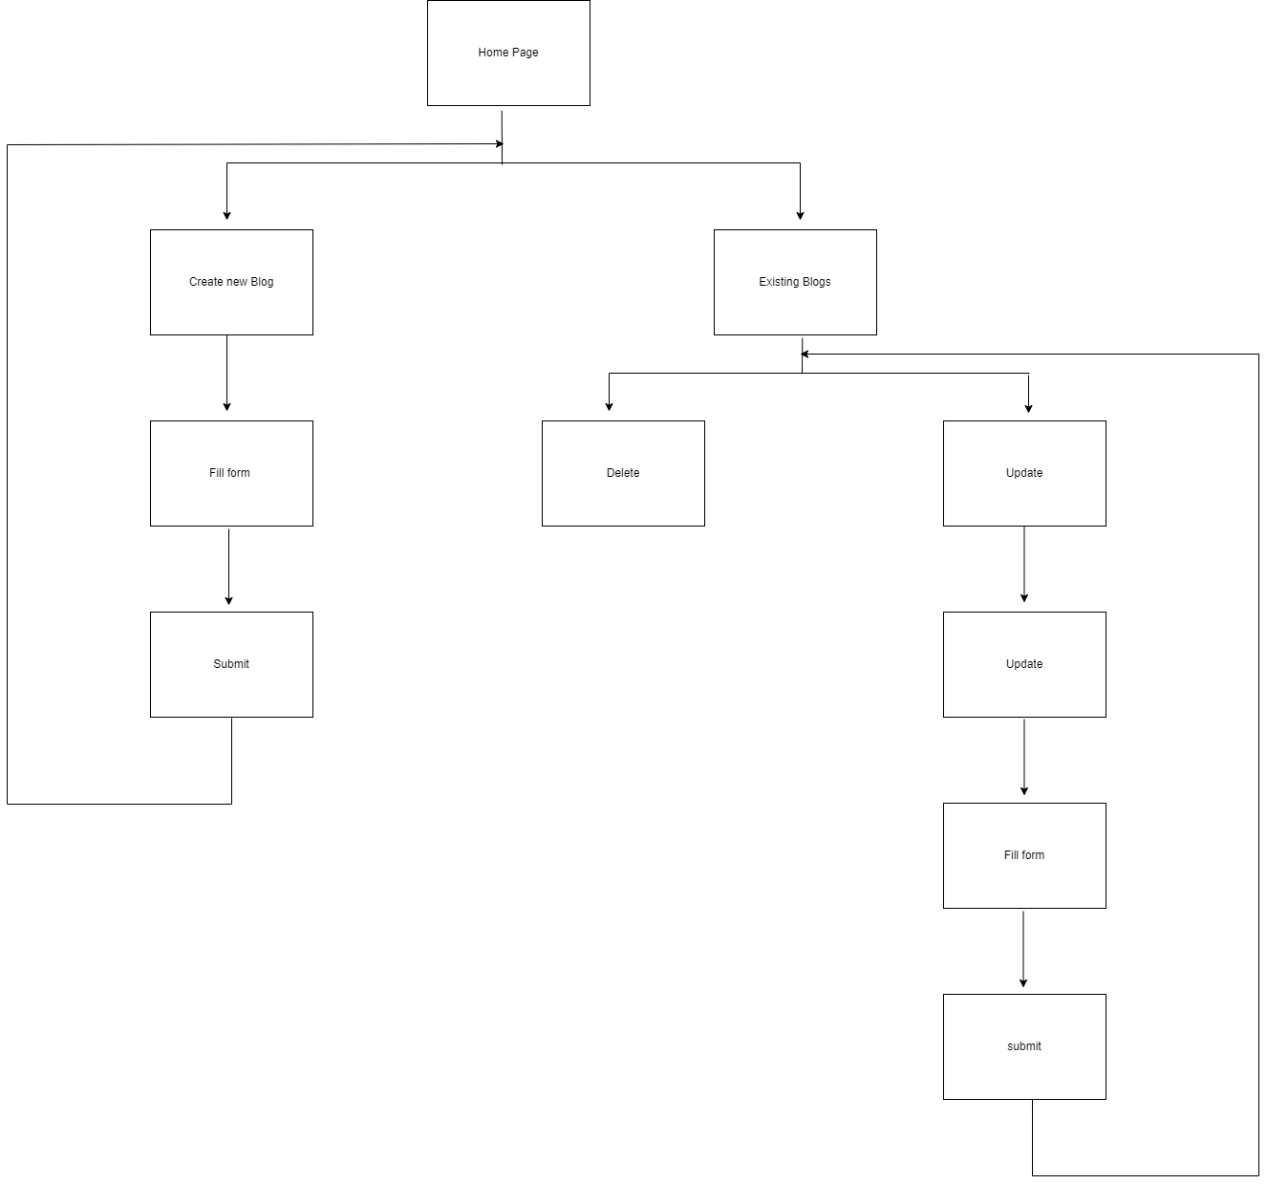

**Algorithm of Application:**

Step 1: START

Step 2: run ng server

Step 3: run json server command to watch json file

Step 4: open url port where server is running(localhost:4000)

Step 5 : Displays application screen

Step 6: Click to create button to create new blog

Step 7: Fill up the form to complete creation by giving title, content and

Image of the blog

Step 8: Submit and click to check new blog

Step 9: Displays new blog created

Step 10: click delete button to delete a particular blog

Step 11: Click update button to change existing blog

Step 12 : Provide values that wanted to change

Step 13 : Submit changes

Step 14: STOP